Access the application here: https://design-document-converter.vercel.app

Step 1: Upload the PPTX Design Document and Client’s Logo
Begin by selecting the Design Document slides in PPTX format and uploading the client’s logo image.
The client’s logo is required to ensure the generated document follows the original template, where the client’s branding (other than the Enfrasys logo) appears:
- In the document header
- On the first page of the document
Important Notes When Preparing the PPTX Slides:
- Ensure all unused or hidden slides are removed and that all remaining slides are visible.
- Arrange the slides in the correct order before uploading.
- Adding Presenter Notes is highly recommended, as it helps the AI better understand the context and intent of each slide.

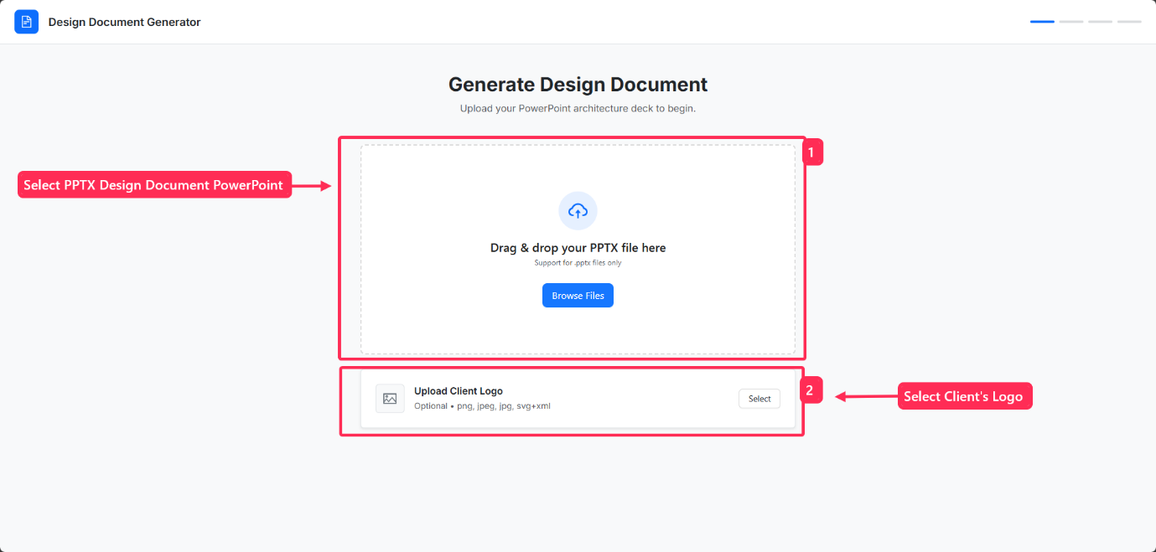
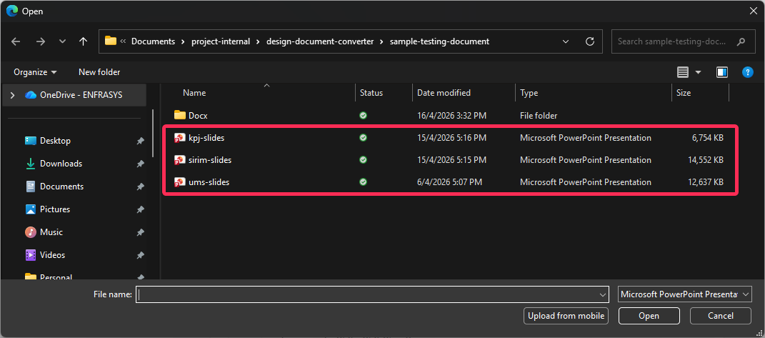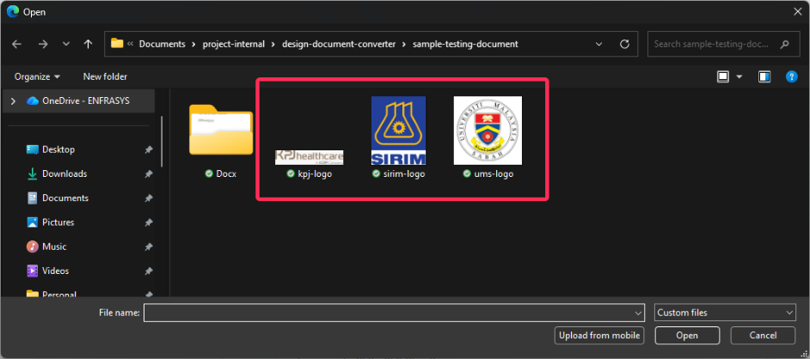

Step 2: Preview Slides and Add AI Insights
After selecting the PowerPoint file and logo image, click “Next: Preview Slides”.
In the Slide Preview page, you will be able to:
- View all extracted slides.
- Review the Presenter Notes from each slide.
You can also select individual slides to add additional context or instructions for the AI, especially for slides that contain images only or minimal text.
Example:
If a slide discusses machine learning but only contains diagrams, you may add notes such as:
“This section uses a Binary Classification Machine Learning algorithm.”
Adding this type of context helps the AI generate more accurate and detailed content in the final Design Document. The added notes will be reflected in the Edit Preview page.
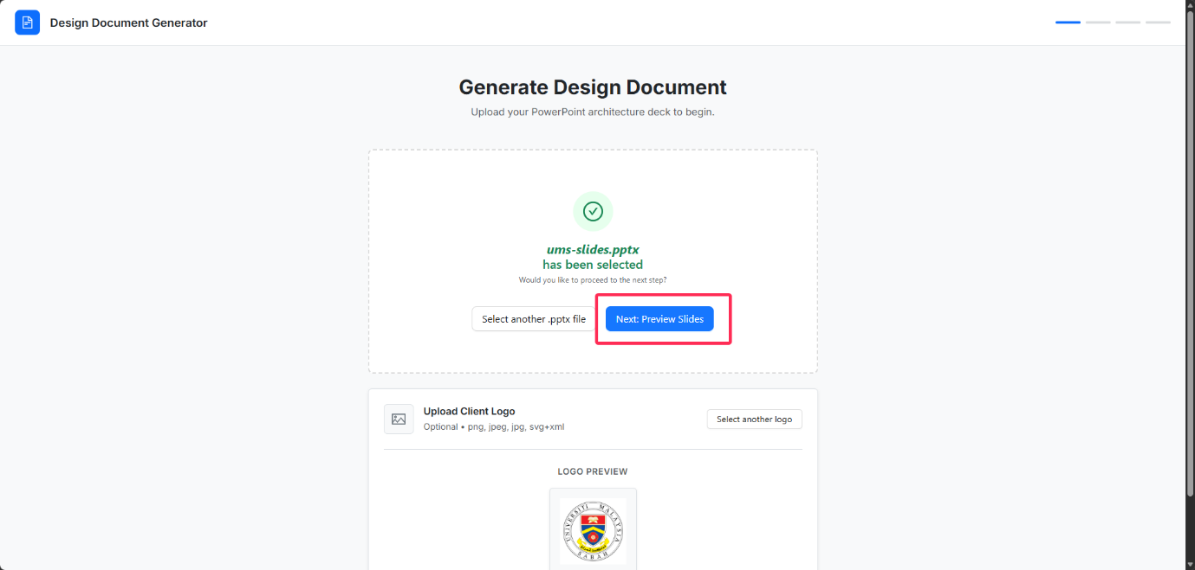
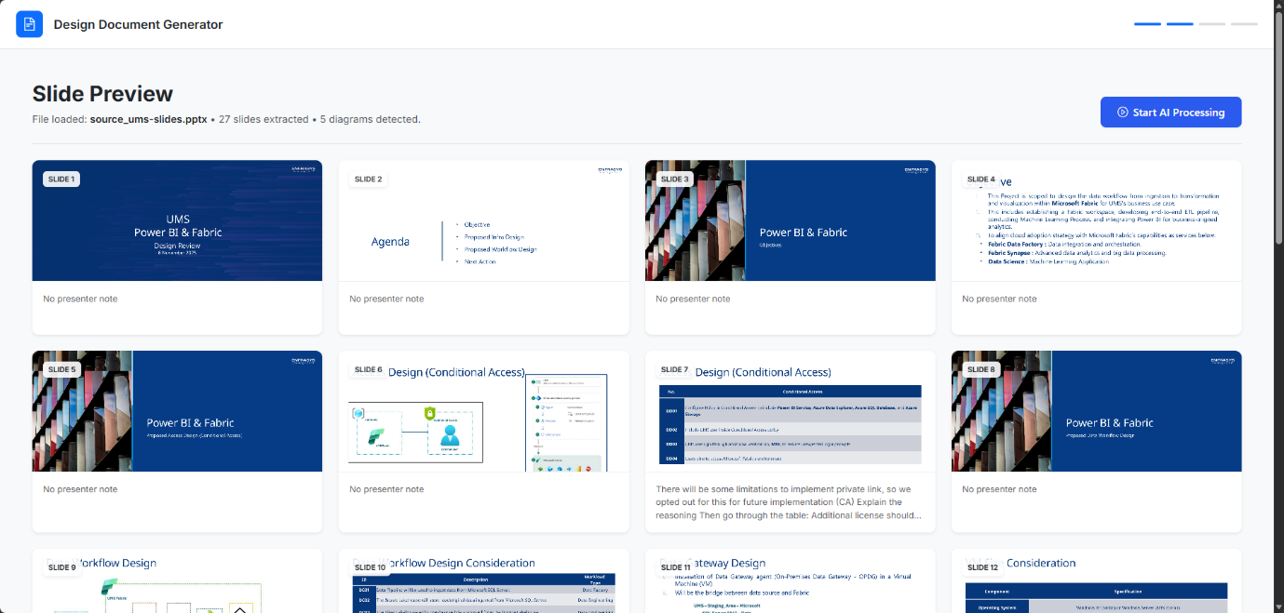
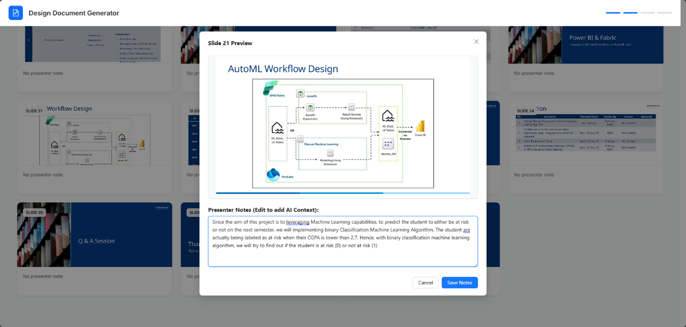

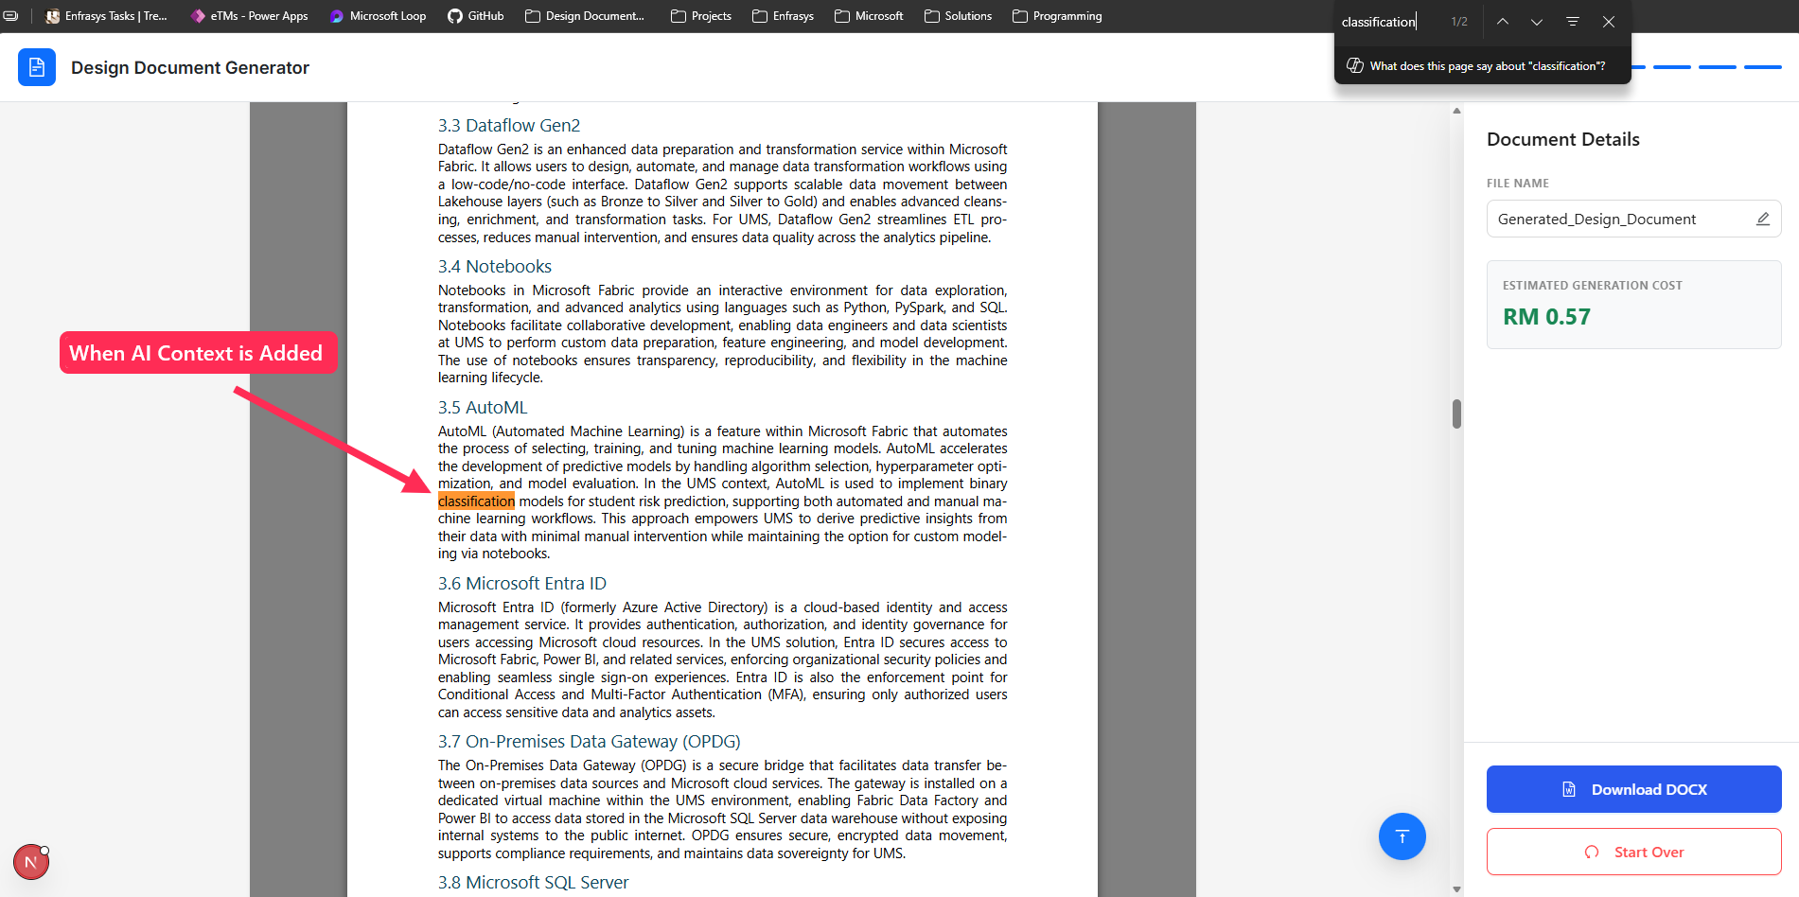

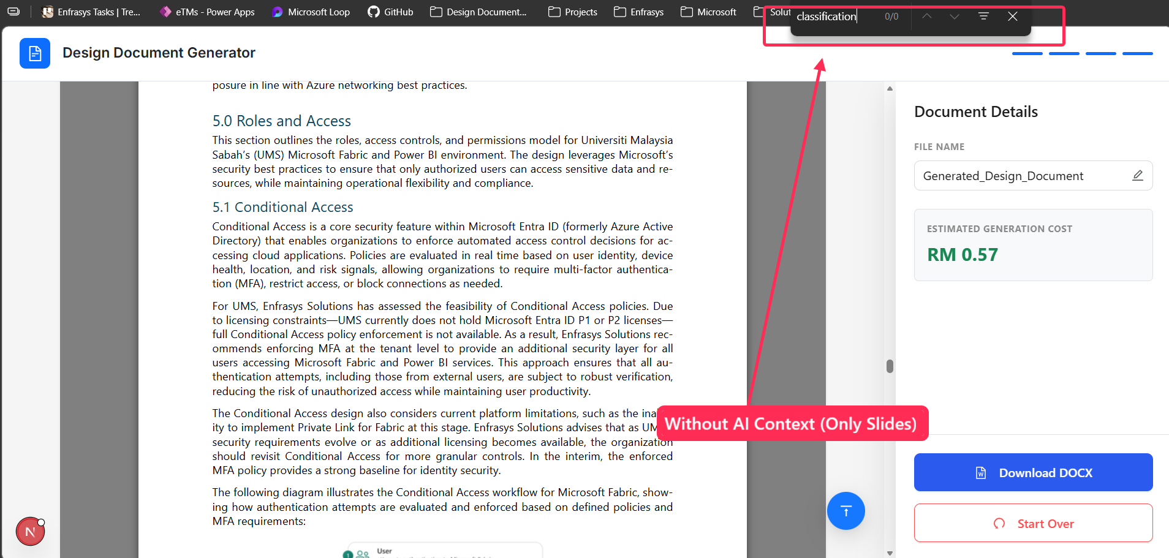

Step 3: Start AI Processing
Once you are satisfied with the slide preview and added context, click “Start AI Processing”.
The system will begin processing the document in the backend. During this time, a processing screen will be displayed to indicate progress.
When processing is complete, click “Preview Generated Document” to continue.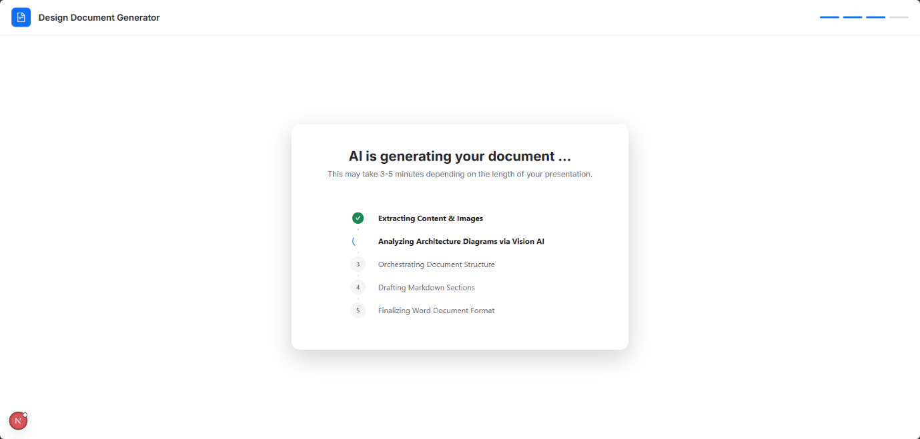
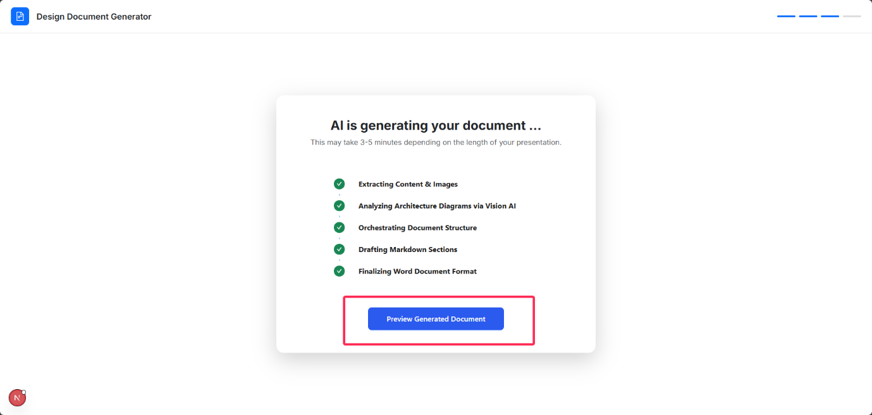

Step 4: Preview, Rename, and Download the Generated Document
On the Preview Docx page, you can:
- Edit or rename the document filename.
- Preview the generated content within the DOCX file
Note: This preview focuses on text content and is not optimized for viewing the full layout or template design.
- Download the generated DOCX document.
- Restart the process using the same document or upload a new document by returning to the first page.
